Data Manipulating Language:

1. Insert your personal data to the employee table as a new employee in department number 30, SSN = 102672, Superssn = 112233.



2. Insert another employee with, personal data your friend as new employee in department number 30, SSN = 102660, but don’t enter any value for salary or supervisor number to him.

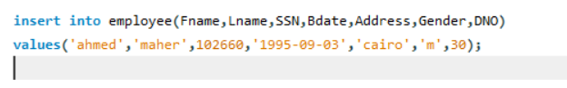

3. In the department table insert new department called "DEPT IT", with id 100, employee with SSN = 112233 as a manager for this department.

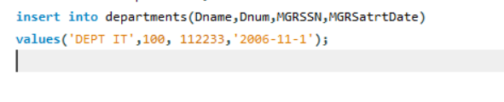

The start date for this manager is '1-11-2006' Try to create the following Queries:

1. Display all the employees’ data.

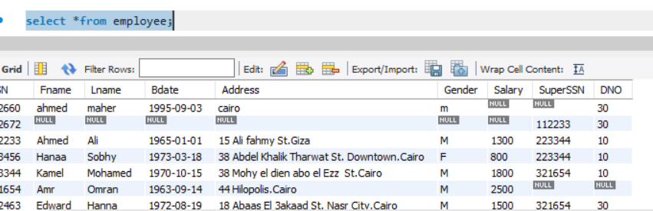

2. Display the employee First name, last name, Salary and Department number.

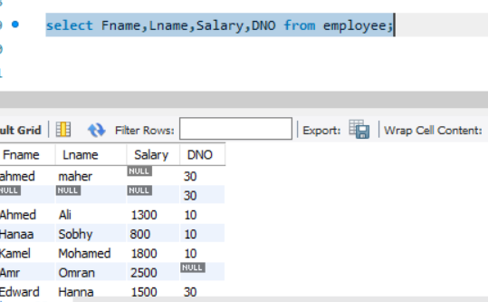

3. Display all the projects names, locations and the department which is responsible about it.

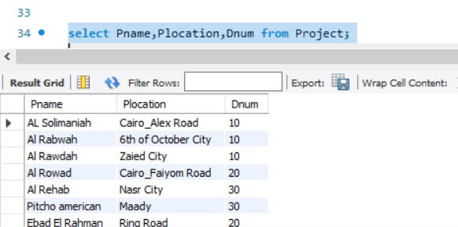

4. If you know that the company policy is to pay an annual commission for each employee with specific percent equals 10% of his/her annual salary. Display each employee full name and his annual commission in an ANNUAL COMM column (alias).

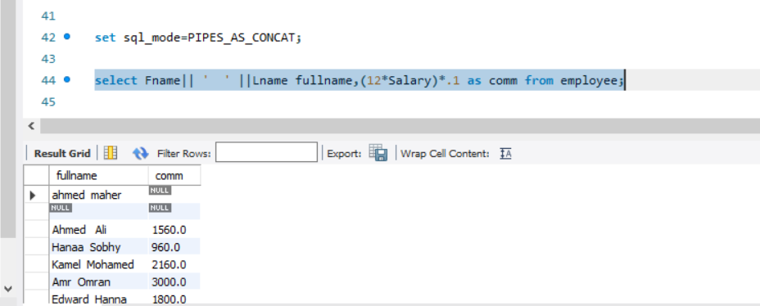

5. Display the employees Id, name who earns more than 10000 LE annually.

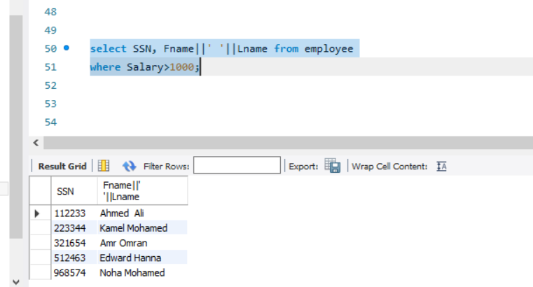

6. Display the names and salaries of the female employees

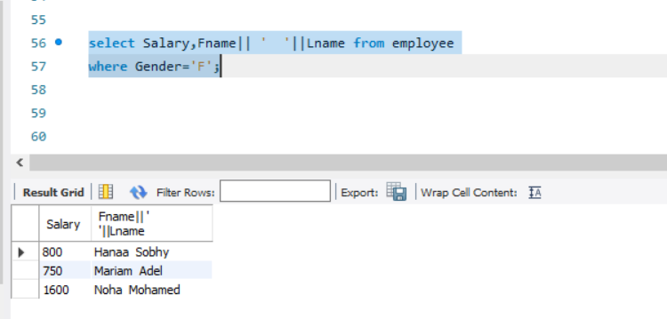

7. Display the Department id, name and id and the name of its manager.

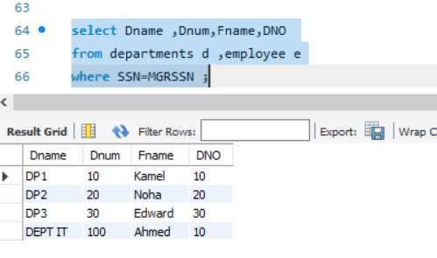

8. Display the Id, name and location of the projects in Cairo or Alex city.

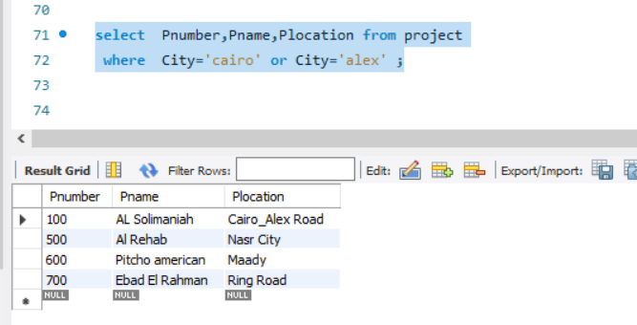

9. Retrieve the names of all employees and the names of the projects they are working on, sorted by the project name.

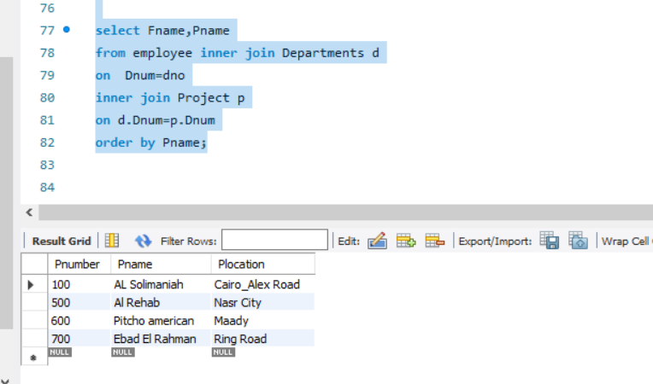

10. Find the names of the employees who directly supervised with Kamel Mohamed

